Program the robot to make a letter “Z”
Use level 3 code to make a letter "Z" and then spin in a loop to celebrate by sensing where to turn using color
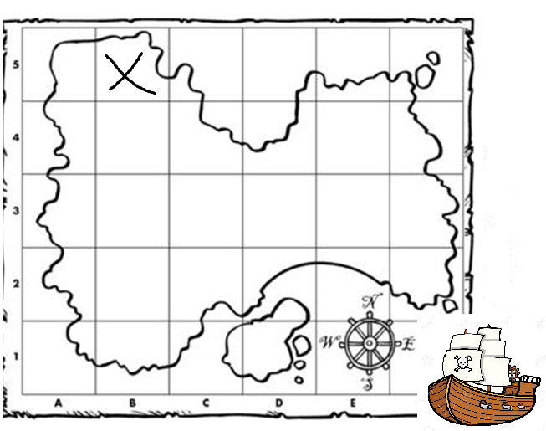
Design clues to get to the treasure from the pirate ship using at least 3 different color commands.
Write out your directions and then code the robot to follow them.

